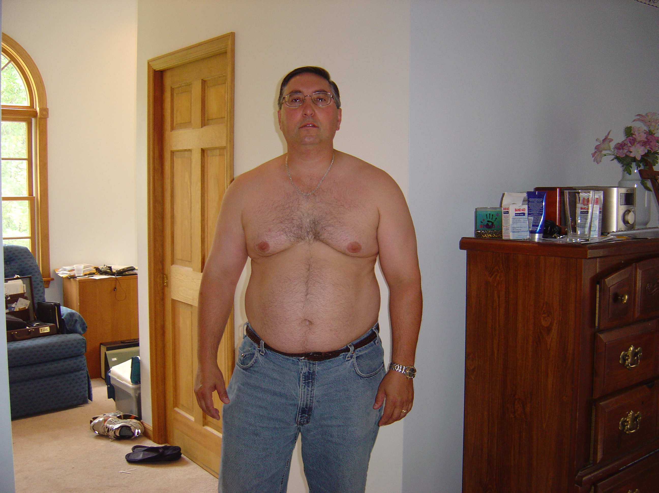
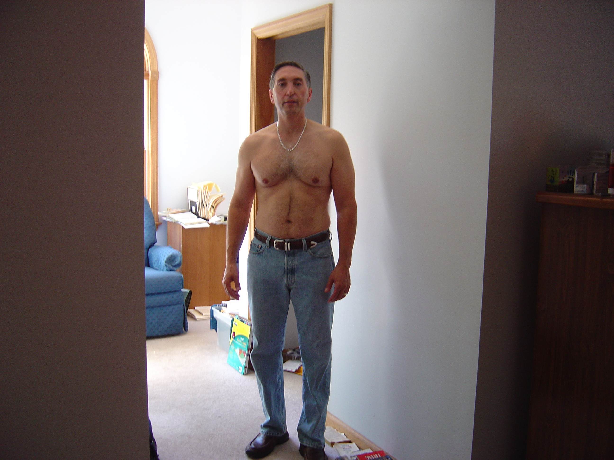

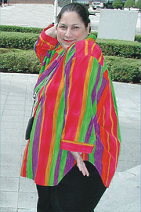
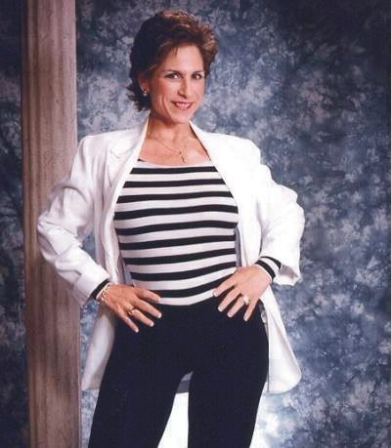
Dominic lost 70 lbs in 4 ½ months and has maintained his weight-loss for 4 years
Mary Jane lost 170 lbs and has kept it off for over 5 years
Doctor Recommended,
Clinically Proven Medifast™
Soy Based Program

Eat six times per day

- No program Fees
- No measuring
- No meetings
- Free Coaching
Take Shape for Life
Weight-loss and Wellness Clinic
Join us on June 14th, 2007 from 6:30 – 7:30 PM
For more information and to register, contact Patti or Mark at:

Family Fitness Center
16 Ridge Road
Anytown, USA 12345
887-Get-Slim
familyfitness@fitusa

The Seminar is free but seating is limited. Please register.
Get In Great Shape for Summer!
Safely Lose up to 20 lbs. per month and keep it off for life

